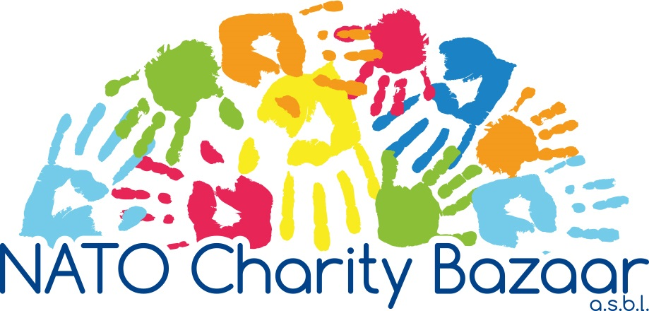

FUNDING APPLICATION
2024

Content List
- Guidelines 2024 2-3

- Checklist 4
- Organisation Information 5
- Banking Information 6

- Project Information 7
- Attachments 8

1. GUIDELINES 2024

NATO CHARITY BAZAAR
The NATO Charity Bazaar ASBL (NCB) has been holding its yearly charity event since 1968. Although, we raise funds throughout the year, the annual NCB Bazaar is the social event of the year within NATO’s international community. Participants in the annual Bazaar are the member nations of NATO and Partnership for Peace (PfP) nations. In 2023, 44 nations were represented.

CHARITY SELECTION PROCESS
- Applications for funding: Of the charities selected, Belgian charities receive 35% of raised funds and International Charities receive 65% of raised funds. The donation is made in December after the Bazaar, provided that the financial information given by the charity on the Application Form is accurate.

Factors taken into account when selecting charities for donation:
- We only consider the funding of requests from organisations which:
- are ASBL or VZW if located in Belgium, are non-governmental organisations and have official registration as a charity (non-profit making organisation) for at least one year prior to the application deadline: 1st May at 12h00 (noon) Central European Time (CET), 2024.
- are small, independent organisations (those which are organisationally and financially independent and NOT a branch of a large parent organisation with a maximum revenue (“income”, “takings”, “receipts” of the organisation) of €334.500 per year and a maximum equity (“own capital”, “assets”, “monetary value” of the organisation) of €1.337.000.)
- exist (or are based) in a NATO Member country, a NATO Partnership for Peace (PfP) country, or a country where NATO is currently engaged.
- For the international charities: have NOT received funds from the NCB for the previous THREE calendar years, i.e., an organisation that benefitted from funds raised at the 2023 Bazaar, and used it for projects in 2024, can next apply in 2027.
- For the Belgian charities: have NOT received funds from the NCB for at least TWO complete calendar years, i.e., an organisation that benefitted from funds raised at the 2023 Bazaar, and used it for projects in 2024, can next apply in 2026.

- Application forms must be fully completed. All questions and requests for explanation MUST be addressed. FAILURE TO DO SO WILL RESULT IN DISQUALIFICATION OF THE APPLICATION.
- One project per application. One application per charity.
- To be considered a Belgian charity applicant, the organisation must exist (or be based) in Belgium.
- We fund projects which:
- are small, specific projects which will be completed during the donation year 2025;
- cover the widest spectrum of the community, and when completed, have a long-term impact and are of benefit to as many people as possible;
  - primarily benefit projects in NATO countries, NATO PfP countries, NCB member countries and countries where NATO is currently operationally engaged. However, we do not exclude projects in other geographic locations.
  - include therapy (considered on case-by-case basis);
  - include purchase of land that is part of the project (considered on a case-by-case basis);
- We do NOT donate funds for the following expenses:
- salaries for the daily staff (staff which work within the organisation on daily basis and receive salary from the organisation for that work) or daily running costs of the applying organisation. Nor do we fund equipment for administrative purposes (i.e., computers, printers, etc.);
- publishing fees for advertisement purposes, as well as media related fees (i.e., web design, radio/TV advertising, radio/TV programs, etc.);
- transportation modes (i.e., bicycle, scooter, motorcycle, car, bus, train, boat, airplane, etc.), with the exception of disability aids (i.e., wheelchairs);
- transportation costs (including gasoline, tickets and the hiring or leasing of transportation, etc.);
- a project that involves a private property.
- The maximum amount donated is €10.000 (euros), however we always strive to give at least the smallest amount required to make the project viable, so that we can fund as many projects as possible.
- The NATO Charity Bazaar members vote and rank the final list of charities to be funded, in order of priority.

APPLICATION PROCESS
- Scan the completed version of this form as well as all of the required, signed documentation into ONE (1) “pdf” file (rename the file to include the name of your organisation) and submit it by e-mail ONLY to charity@natocharitybazaar.org. The two photos should be sent in “jpeg” format, in the same email.

- REMEMBER: Rename the application file and photo files to include the name of your organisation
- The subject line of the e-mail MUST include the name of the applying organisation.
- Direct any questions by e-mail to charity@natocharitybazaar.org
- Proposals are due by 1st MAY at 12h00 (noon) Central European Time (CET) 2024. If funding is awarded, the funds will be transferred in December 2024 with a Hybrid Donation Ceremony in January 2025.
- All correspondence must be in English or French.
- Failure to provide ALL of the above information requested will result in the disqualification of the application.
- All eligible Belgian charities may or not receive a personal visit from a representative of the NCB.

FEEDBACK
- Organisations that receive funding will be requested to provide a short report on their project, which must include receipts for goods or equipment purchased and possibly some photographs by January 2026.

2. CHECKLIST

Have you included ALL of the requested documentation?
Failure to do so will result in the disqualification of your request for funding.

 | Page in the application form | 
Legal name, address, e-mail and/or website address (if available) | 6
Official number of non-profit, non-governmental, charity status | 6
Official date your organisation was established | 6
Name, title, e-mail address and telephone number of your organisation’s contact person | 6
Name, e-mail address and telephone number of your NATO or PfP or NCB member contact person (not mandatory) | 6
A brief summary of your organisation’s history and mission in English or French (Attachment 1) Max 150 words in Word-format | Att 1
Proof of non-governmental/non-profit/charity status and existence for minimum of one year as of the application deadline, in the form of the latest version of a signed, dated, officially stamped registration form or certificate of authenticity from the registry office showing status (in Belgium ASBL or VZW certificate) including a translation in English or French. (Attachment 2) | Att 2
An official letter from the bank dated in the year of the application in English or French stating that the bank account is in the name of the requesting organisation (include IBAN, BIC – also known as SWIFT - codes or ABA/Routing Transit Number (USA). The official letter must be signed, dated, and officially stamped by the bank. (Attachment 3) | Att 3
Specification of the preferred currency for deposit | 7
Signature of your organisation’s Treasurer and date thereof | 7
Signature of your organisation’s Executive Director and date thereof | 7
Proof of the size of your organisation in the form of the most recent (not older than two years) financial statements (annual balance sheet as well as profit and loss account) signed, dated and stamped by authorized official. Both original and translated documents MUST be sent. (Attachment 4) | Att 4
A summary of the proposed project in English or French (Attachment 5) Max 100 words in Word-format | Att 5
Time frame of the project (projected start and completion month/year). The project must end in 2025. | 8
Geographical location of the project (city, street, state or region, country) | 8
The impact of this project and its target population | 8
Total project cost in € (euros) and the minimum amount required to make a viable project | 8
Itemized project budget/complete breakdown of the project (including materials and costs) This itemized budget, in € (euros), must match the amount requested. (Attachment 6) | Att 6
Order of importance/priority for funding if there are separate parts to your project. A breakdown of minimum amount required to make the project viable project (Attachment 7) | Att 7
Two (2) recent digital photographs of your organisation and its work – in one or two separate emails

3. ORGANISATION INFORMATION

Complete this form by filling in the information electronically.
Answer each question completely.
All written material must be submitted electronically – preferably in one e-mail.
- Legal name of organisation: _____________________________________________________

- Mailing Address for Official Correspondence (city, street, state or region, country): __________
___________________________________________________________________________
- Email Address: ______________________________________________________________
- Web Address: ______________________________________________________________

- Official registration number of the organisation as a non-governmental, non-profit organisation (ASBL or VZW if in Belgium) ____________________________________________________________________________
- Date established as a non-governmental, non-profit organisation (ASBL or VZW if in Belgium) _______________________________________________________________

- Name and Title of Organisation Contact Person (CP): _______________________________
- CP Email Address: ___________________________________________________________
- CP Telephone #: ____________________________________________________________
- CP can speak: English: ☐ French: ☐

- Name of NATO Contact Person: ________________________________________________
- Email Address of NATO Contact Person: _________________________________________
- Telephone Number of NATO Contact Person: _____________________________________

4. BANKING INFORMATION

Complete this form by filling in the information electronically.
Answer each question completely.
All written material must be submitted electronically – preferably in one e-mail.

Name of Bank__________________________________________________________________________

Bank Address (city, street, state or region, country) ____________________________________________

_____________________________________________________________________________________

Bank Account Name (as registered by the organisation’s bank)

Bank Account Number:

IBAN Number (International Bank Account Number):

BIC Number (Bank Identifier Code - also known as Swift Address):

Routing Number/ or ABA number (for U.S. banks):

Preferred currency for deposit:

Signature of Organisation’s Executive Director: |  | Date:

Signature of Organisation’s Treasurer: |  | Date:

2023 Revenue: €______________ National Currency: __________________ (must include documentation, see checklist for specifics) Please state in both € and national currency
2023 Equity: €________________ National Currency: ____________________ (must include documentation, see checklist for specifics) Please state in both € and national currency

5. PROJECT INFORMATION

Complete this form by filling in the information electronically.
Answer each question completely.
All written material must be submitted electronically – preferably in one e-mail.
- What is the name of the project? _______________________________________________________
- Is the name of the project the same as the name of the organization? Yes/No

- The project must be completed within a 12-month time frame and must be completed no later than 31st December 2025.

- Project Time Frame: (DD/MM/YYYY) ______________ to ____________________
- Geographic Location of the Project (provide city, street, state and country):
__________________________________________________________________________
- Estimated number of people affected by the project: _____________________________
- Focus of project (can be more than one):
 | Health |  | Women |  | People with disabilities
 | Environment |  | Children |  | Other, please explain below
 | Education |  | Senior

_______________________________________________

PROJECT BUDGET

Total Project Cost € (euros) _____________________

Minimum amount required to make the project viable € (euros) ______________________

6. REQUIRED ATTACHMENTS

Please provide the following information.
All written material must be submitted electronically – preferably in one e-mail.

Required Attachments (All attachments MUST be in English or French)

The application MUST include all of the following documentation:

- A brief summary of your organisation’s history and mission in English or French, max 150 words in Word document.

- Proof of non-governmental / non-profit / charity organisation status and existence for a minimum of one year in the form of the latest signed, dated, and officially stamped registration form or certificate of authenticity from the registry office showing status (in Belgium VZW or ASBL certificate) including a translation in English or French. (The translation does not need to be officially certified.)

- An official letter from the bank dated in the year of the application in English or French stating that the bank account is in the name of the requesting organisation (include IBAN, BIC – also known as SWIFT – codes or ABA/Routing Transit Number (USA). The official letter must be signed, dated and officially stamped by bank official. NO DONATION SHALL BE MADE TO A PERSONAL ACCOUNT.

- Proof of the size of your organisation in the form of the most recent (not older than two years) financial statements (annual balance sheet as well as profit and loss account) signed, dated and stamped by authorized official. Both original and translated documents MUST be sent.

- A summary of the proposed project in English or French, max 100 words in Word format

- An itemized project budget with details of breakdown of all costs, in order of importance. The budget must match the amount requested. A breakdown of minimum amount required to make a viable project must be included.

- Two (2) recent digital photographs (in “jpeg” format) of your organisation and its work, submitted with your application. If your organisation is deemed eligible for funding, these pictures will appear on our web site as well as in our publications including social media. By sending the photos with this application, you are giving your authorization to the NATO Charity Bazaar to use them in NATO Charity Bazaar publications, printed and electronically.

Non-compliance with any of the above will lead to automatic disqualification of the project.

